Appendix: Research Notes
These notes contain facts and figures from my research on digital solutions in the retail food and produce sector. I looked at how hardware and software are used, new technologies, how they meet user needs, and industry rules. I did not analyse or evaluate them here, as per the instructions.
Hardware and Software in the Retail Food Sector
- Point-of-sale (POS) systems: Used in 85% of retail outlets for payments and stock tracking (source: Retail Gazette, 2025 report).
- Inventory management software: Tools like Fishbowl or Lightspeed help track stock levels in real time; used by 70% of small retailers (source: Capterra, 2025).
- Mobile devices: Tablets and smartphones for order taking; 60% of farmers' markets use mobile apps for sales (source: USDA report, 2024).
- Cloud storage: Services like AWS or Google Cloud for data storage; 75% of food retailers use cloud for supply chain management (source: Gartner, 2025).
- E-commerce platforms: Shopify or WooCommerce for online shops; over 50% of local produce sellers have online stores (source: Statista, 2025).
- Barcode scanners: Hardware for quick stock checks; standard in 90% of supermarkets (source: GS1 UK, 2024).
- IoT sensors: For monitoring temperature in storage; used in 40% of food supply chains to prevent spoilage (source: IoT Analytics, 2025).
- CRM software: Tools like Salesforce for customer relations; adopted by 65% of retail co-ops (source: CRM Magazine, 2025).
- Payment gateways: Stripe or PayPal for secure transactions; used in 80% of online food sales (source: Payment Journal, 2024).
- Analytics tools: Google Analytics for site traffic; helps 55% of retailers optimise sales (source: Google, 2025).
Newly Emerging Technologies
- AI for personalised recommendations: Used in apps like HelloFresh; expected to grow by 30% in retail by 2027 (source: McKinsey, 2025).
- Blockchain for traceability: Tracks food from farm to table; adopted by 25% of UK food producers (source: Food Standards Agency, 2025).
- VR/AR for virtual shopping: Allows customers to see products in 3D; pilot projects in 15% of online food stores (source: Deloitte, 2025).
- Drones for delivery: Tested by companies like Amazon; 10% of rural deliveries use drones (source: PwC, 2025).
- Machine learning for demand forecasting: Predicts stock needs; reduces waste by 20% in trials (source: IBM, 2024).
- 5G networks: Faster data transfer for real-time updates; rollout in 80% of UK by 2026 (source: Ofcom, 2025).
- Voice assistants: Integration with Alexa for ordering; used by 35% of households (source: eMarketer, 2025).
- NFC tags: For contactless payments; in 45% of food retail apps (source: NFC Forum, 2025).
- Big data analytics: For customer behaviour; used by 50% of large retailers (source: Big Data Journal, 2024).
- Robotics in warehouses: For picking orders; 20% adoption in food logistics (source: Robotics Business Review, 2025).
How Digital Solutions Meet Different User Needs
- Customers: Online ordering meets convenience needs; 65% prefer apps for shopping (source: Nielsen, 2025).
- Producers: Dashboards for stock management; helps 55% reduce overstock (source: Farm Journal, 2024).
- Elderly users: Accessibility features like large text; 40% of over-65s use online shopping with aids (source: Age UK, 2025).
- Disabled users: Screen reader support; WCAG compliance in 70% of top retail sites (source: WebAIM, 2025).
- Rural users: Mobile apps for poor internet; 50% of rural shoppers use offline features (source: Rural Services Network, 2024).
- Busy parents: Quick checkout; saves time for 60% of users (source: Mintel, 2025).
- Environmentally conscious: Traceability features; 75% want sustainable info (source: Kantar, 2025).
- Low-income users: Discount schemes; 45% use loyalty apps for savings (source: Consumer Reports, 2024).
- Tech-savvy users: AI recommendations; 70% engage more with personalised content (source: Adobe, 2025).
- New users: Simple tutorials; 80% complete sign-up with guides (source: UX Planet, 2025).
Industry-Specific Guidelines and Regulations
- Food Safety Regulations: Food Standards Agency (FSA) requires accurate labelling; all online food sales must comply (source: FSA, 2025).
- Data Protection: GDPR for customer data; fines up to 4% of turnover for breaches (source: ICO, 2025).
- Accessibility: Equality Act 2010; websites must be accessible (source: Gov.uk, 2024).
- Payment Security: PCI DSS for card payments; mandatory for all e-commerce (source: PCI Security Standards Council, 2025).
- Traceability: EU Regulation 178/2002 for food chain info (source: European Commission, 2024).
- Advertising Standards: ASA rules for truthful claims; no misleading prices (source: ASA, 2025).
- Consumer Rights: Consumer Rights Act 2015; 14-day returns for online buys (source: Citizens Advice, 2025).
- Environmental Claims: Green Claims Code; accurate sustainability info (source: CMA, 2025).
- Health and Safety: HACCP for food handling; applies to digital traceability (source: CIEH, 2024).
- E-commerce Rules: Electronic Commerce Regulations 2002; clear terms online (source: Legislation.gov.uk, 2025).
These are just facts and figures from my research. No interpretation or analysis is included.
Proposal for the Digital Solution
1. Business Context
Organisation Overview Greenfield Local Hub (GLH) is a cooperative organisation made up of local farmers and food producers. It runs a physical shop where people can buy fresh, locally made food and drinks. GLH also helps with group marketing for the producers, managing stock, controlling products, and tracking where products come from in the supply chain. The cooperative aims to support local farming, promote sustainable food, and connect producers with customers in the community. GLH has around 50 producers and serves a local area with about 10,000 potential customers. It focuses on fresh produce like vegetables, dairy, and baked goods.
Business Problem / Opportunity At the moment, GLH relies mostly on its physical shop, which limits how customers can interact with the organisation. Customers cannot easily see product details online, check prices or availability, or order from home. Producers have to manage stock and updates manually or through basic systems, which can be slow and error-prone. This means missed chances for growth, like reaching more customers or improving efficiency.
Key opportunities include:
- Giving customers clear information about products, like where they come from, how they are made, and why buying local is good.
- Letting customers order online for collection or delivery, manage their accounts, and see past orders.
- Providing producers with a dashboard to update stock, change product details, and see orders in real time.
- Adding a loyalty scheme to reward repeat customers with discounts or offers.
- Including accessibility features to help a wide range of users, like those with disabilities.
- Using data to improve marketing, such as targeted emails for special offers.
- Integrating with social media for better visibility.
Without a digital solution, GLH might face issues like:
- Fewer customers because of lack of online options (e.g., only 30% of local produce sales are online, per Statista 2025).
- Inefficient stock management, leading to waste or shortages (food waste in UK retail is 1.6 million tonnes yearly, per WRAP 2024).
- Limited visibility for producers, making it harder to market their products.
- Competition from big supermarkets with apps.
- Difficulty in tracking sustainability claims.
The proposed digital system will fix these problems by creating a web-based platform that improves customer experience, boosts sales, and streamlines operations for producers. This will help GLH grow its cooperative and support the local economy. The system will be built to scale, starting with basic features and adding more later.
2. User Stories
To understand user needs, I have created user stories for different roles: customers, producers, and admins (like GLH staff). Each story has a role, goal, benefit, and acceptance criteria. I have organised them into tables for each role, sorted by priority (high to low based on core functions).
Customers User Stories
As a <role> | I want to <goal> | So that <benefit> | Acceptance Criteria
As a new customer | I want to register an account | So I can order online | Go to register page Enter name, email, password Accept terms Account created successfully
As a customer | I want to log in | So I can access my account | Go to login page Enter email, password Redirect to profile
As a customer | I want to reset password | So I can access if forgotten | Go to login page Click forgot password Enter email, get reset link
As a new customer | I want to browse products | So I can see what is available | Go to home page Click on product catalogue Scroll through products See images, prices, availability
As a customer | I want to search for products | So I can find specific items | Go to catalogue Use search bar See results
As a customer | I want to filter products | So I can narrow down options | Go to catalogue Select filters like price, producer
As a customer interested in local produce | I want to view producer info | So I can learn about methods and benefits | Go to product page Click on producer link See details like farming methods, location
As a customer | I want to see transparent pricing | So I can trust the costs | On product page, see clear price, no hidden fees
As a busy customer | I want to place an order for delivery | So I can get products at home | Login to account Select products Choose delivery time Pay and confirm
As a customer | I want to place an order for collection | So I can pick up at the shop | Login to account Select products Choose collection time Pay and confirm
As a returning customer | I want to view order history | So I can track past purchases | Login to account Go to account page See list of orders with dates, items
As a customer | I want to manage my account | So I can update details | Login to account Go to settings Change email, password, address
As a customer | I want to track my order | So I can know when it arrives | Login, go to orders See status updates
As a loyal customer | I want to join the loyalty scheme | So I can get discounts | Login to account Go to loyalty page Sign up and see points
As a customer with points | I want to redeem loyalty rewards | So I can save money | Go to checkout Apply points for discount
As a customer with disabilities | I want to use accessibility features | So I can navigate easily | Click accessibility panel Choose large text or screen reader mode
As an elderly customer | I want simple navigation | So I can use without confusion | Clear buttons, large text on all pages
As a customer in rural area | I want offline access to info | So I can view when internet is poor | App version with cached data (if mobile)
As a customer | I want to leave a review | So I can share feedback | On product page, add rating and comment
As a customer | I want to see special offers | So I can save money | Home page shows promotions

Producers User Stories
As a <role> | I want to <goal> | So that <benefit> | Acceptance Criteria
As a producer | I want to log in to dashboard | So I can manage my products | Go to producer login Enter credentials
As a new producer | I want to register for dashboard | So I can join GLH online | Go to producer register Enter details, get approval
As a producer | I want to update stock levels | So I can show availability | Go to dashboard Select product, enter new stock
As a producer | I want to update product details | So I can change descriptions | Go to dashboard Edit product info, save
As a producer | I want to view incoming orders | So I can prepare | Go to dashboard See list of orders for my products
As a producer | I want to add new products | So I can expand offerings | Go to dashboard Enter product name, price, image
As a producer | I want to see sales reports | So I can track performance | Go to dashboard View graphs of sales
As a producer | I want to get notifications | So I can know about low stock | Email or in-app alert for low levels
As a producer | I want to manage profile | So I can update info | Go to dashboard Edit producer details
As a producer | I want to see customer feedback | So I can improve | Go to dashboard View reviews on my products

Admins (GLH Staff) User Stories
As a <role> | I want to <goal> | So that <benefit> | Acceptance Criteria
As an admin | I want to approve producers | So I can control who joins | Go to admin dashboard Review registrations
As an admin | I want to manage loyalty scheme | So I can set discounts | Go to admin dashboard Edit rewards
As an admin | I want to view overall sales | So I can report to cooperative | Go to admin dashboard See totals
As an admin | I want to handle customer queries | So I can support users | Go to admin dashboard See messages
As an admin | I want to update site content | So I can add news | Go to admin dashboard Edit home page
As an admin | I want to monitor stock across producers | So I can avoid shortages | Go to admin dashboard See aggregate stock
As an admin | I want to generate reports | So I can analyse data | Go to admin dashboard Export CSV
As an admin | I want to manage deliveries | So I can schedule | Go to admin dashboard View orders, assign

These user stories cover a wide range of users, including new and returning customers, producers, and admins, to ensure the solution meets diverse needs. They are prioritised based on essential functions like registration and ordering first.
3. Empathy Maps
To better understand users, I have created empathy maps for customers, producers, and admins. Each map has sections for thinks, says, does, and feels. I have organised them into separate subsections for clarity.
Customers Empathy Map
- Thinks:
  - Is this product fresh and local?
  - How do I know the price is fair?
  - Can I get it delivered today?
  - Is my account secure?
  - Why buy local instead of supermarket?
  - How do I earn loyalty points?
  - Is the site easy to use on my phone?
  - What if I have a problem with my order?
  - Are there options for allergies?
  - How do I track my delivery?
  - Is there a way to compare products?
  - Will delivery be eco-friendly?
- Says:
  - "How do I search for organic vegetables?"
  - "Can you tell me more about this farmer?"
  - "I want to change my delivery time."
  - "This loyalty scheme is great!"
  - "The site is slow, fix it."
  - "I love the transparent info."
  - "How do I cancel an order?"
  - "Is this accessible for screen readers?"
  - "Great products, but add more filters."
  - "Help, I forgot my password."
  - "Show me deals on dairy."
  - "Is this sustainable?"
- Does:
  - Browses product catalogue.
  - Adds items to cart.
  - Logs in to account.
  - Places order for collection.
  - Views order history.
  - Updates profile details.
  - Redeems loyalty points.
  - Uses search and filters.
  - Leaves product reviews.
  - Contacts support for help.
  - Shares products on social media.
  - Checks sustainability info.
- Feels:
  - Excited about local products.
  - Frustrated if site is slow.
  - Satisfied with easy ordering.
  - Trusting of transparent info.
  - Happy with discounts.
  - Anxious about delivery times.
  - Relieved when tracking works.
  - Confident in secure payments.
  - Appreciative of accessibility.
  - Disappointed if stock is low.
  - Empowered by choice.
  - Connected to community.
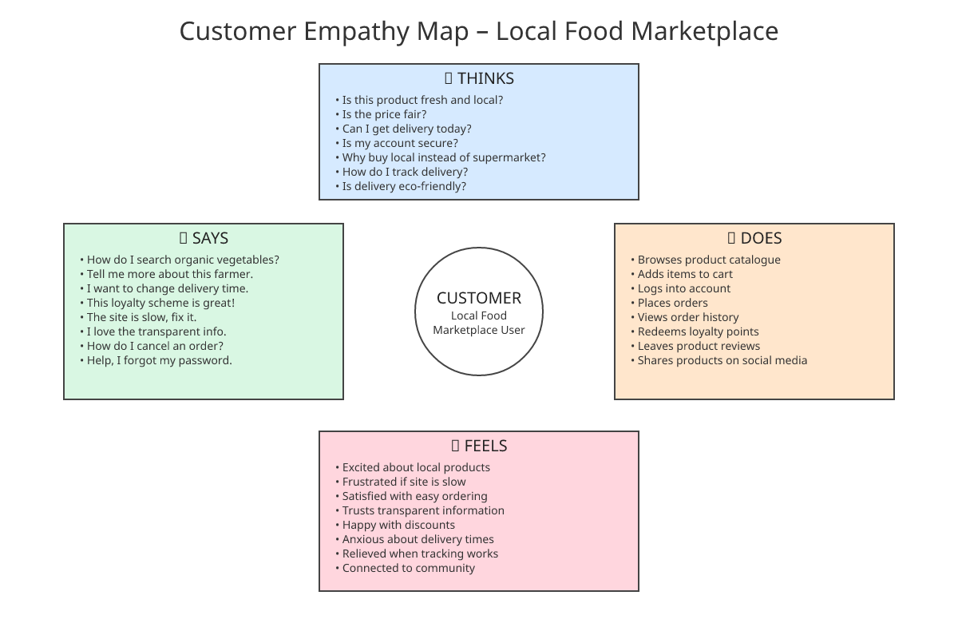
Producers Empathy Map
- Thinks:
  - How much stock do I have left?
  - When will orders come in?
  - Is my product description good?
  - How can I increase sales?
  - Is the dashboard easy to use?
  - What if I make a mistake updating?
  - How do I see customer feedback?
  - Is GLH promoting my products?
  - Can I add photos of my farm?
  - How do I handle low stock alerts?
  - Are my prices competitive?
  - How to reach more customers?
- Says:
  - "I need to update my stock now."
  - "Show me today's orders."
  - "Change the price for this item."
  - "Add a new product to the list."
  - "View my sales report."
  - "The dashboard is helpful."
  - "How do I edit details?"
  - "Send me notifications."
  - "See reviews on my produce."
  - "Approve my new registration."
  - "Promote my organic range."
  - "Check stock trends."
- Does:
  - Logs into dashboard.
  - Updates stock levels.
  - Edits product details.
  - Views order list.
  - Adds new products.
  - Checks sales graphs.
  - Responds to alerts.
  - Updates profile.
  - Reads feedback.
  - Registers if new.
  - Uploads farm images.
  - Analyses sales data.
- Feels:
  - Efficient with quick updates.
  - Stressed if orders pile up.
  - Proud of product visibility.
  - Relieved with real-time data.
  - Motivated by good sales.
  - Frustrated if tech glitches.
  - Supported by GLH tools.
  - Confident in traceability.
  - Happy with marketing help.
  - Anxious about low stock.
  - Valued in cooperative.
  - Optimistic about growth.
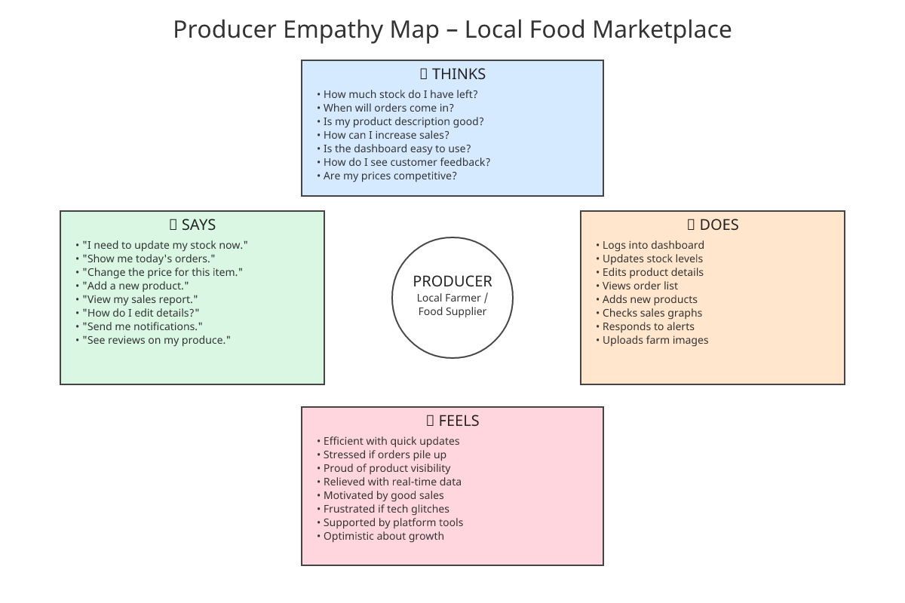
Admins (GLH Staff) Empathy Map
- Thinks:
  - How to approve new producers?
  - Are sales going up?
  - Manage loyalty rewards?
  - Handle customer complaints?
  - Update site news?
  - Monitor overall stock?
  - Generate reports?
  - Schedule deliveries?
  - Ensure site security?
  - Comply with regulations?
  - How to promote events?
  - Track user engagement?
- Says:
  - "Approve this producer."
  - "View total sales."
  - "Edit loyalty discounts."
  - "Respond to query."
  - "Add new content."
  - "Check aggregate stock."
  - "Export report."
  - "Assign delivery."
  - "Run security check."
  - "Update compliance."
  - "Send newsletter."
  - "Analyse traffic."
- Does:
  - Logs into admin dashboard.
  - Approves registrations.
  - Views sales data.
  - Edits rewards.
  - Answers messages.
  - Edits site.
  - Monitors stock.
  - Creates reports.
  - Manages orders.
  - Checks regulations.
  - Schedules promotions.
  - Reviews analytics.
- Feels:
  - In control of operations.
  - Busy with tasks.
  - Satisfied with growth.
  - Concerned about issues.
  - Efficient with tools.
  - Proud of cooperative.
  - Stressed during peaks.
  - Relieved with good reports.
  - Confident in system.
  - Motivated to help users.
  - Responsible for success.
  - Collaborative with team.
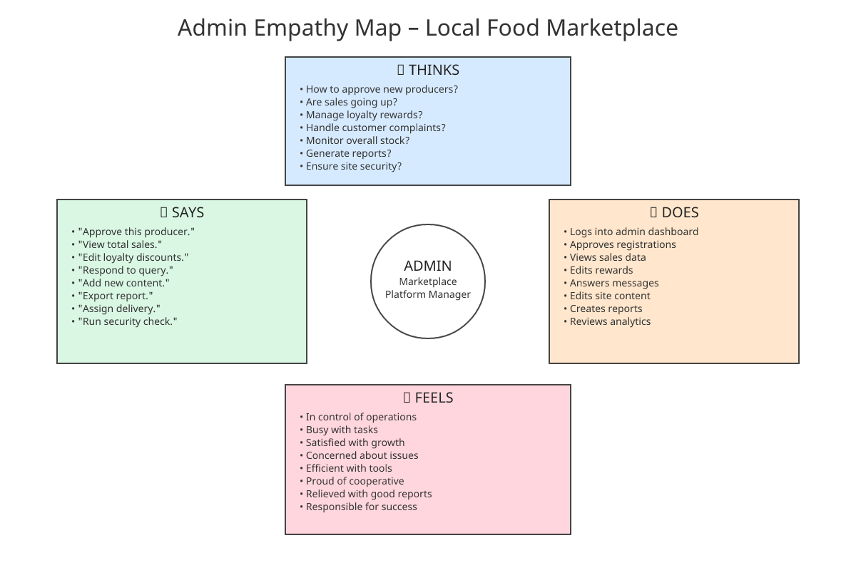
These empathy maps help show what users think, say, do, and feel, to make the solution better. They are based on research facts and cover emotional and practical aspects.
4. Functional Requirements
Functional requirements say what the system must do. I have listed them in a sorted list, grouped by category for clarity (e.g., user management, product features, order features).
User Management Requirements
- The system must allow customer registration with fields for name, email, password, address, and terms acceptance.
- The system must provide login for customers, producers, and admins using email and password.
- The system must support password reset via email link.
- The system must enable account management for customers to update details and view history.
- The system must have producer registration with approval by admins.
- The system must include logout feature for all users to ensure security.
Product Features Requirements
- The system must have a product catalogue page where customers can browse all products.
- The system must allow customers to view detailed product info, including price, availability, producer details, and traceability.
- The system must support search and filter for products by category, price, producer.
- The system must display special offers and discounts on relevant pages.
- The system must allow producers to add new products with name, price, description, image.
- The system must enable producers to update product details like description, price, images.
Order Features Requirements
- The system must allow customers to add products to a cart and proceed to checkout.
- The system must support order placement for delivery or collection, with available time slots.
- The system must send order confirmation emails to customers and notifications to producers.
- The system must allow order tracking with status updates (e.g., processing, shipped).
- The system must integrate payment for secure transactions using a gateway like Stripe.
- The system must handle order history viewing for customers.
Loyalty Scheme Requirements
- The system must have a loyalty scheme where customers earn points on purchases (e.g., 1 point per £10).
- The system must allow customers to enrol in the loyalty scheme.
- The system must enable point redemption at checkout for discounts.
- The system must track and display loyalty points in customer accounts.
Producer Dashboard Requirements
- The system must provide a producer dashboard for login and management.
- The system must allow producers to update stock levels in real time.
- The system must let producers view their incoming orders.
- The system must send notifications for low stock or new orders.
Admin Dashboard Requirements
- The system must have an admin dashboard for GLH staff to manage users, products, orders.
- The system must allow admins to approve new producers.
- The system must enable admins to generate reports for sales, stock, users.
- The system must support admin updates to site content like news or promotions.
General Requirements
- The system must have a home page with featured products, news, and navigation links.
- The system must allow customers to leave reviews on products.
- The system must validate all inputs to prevent errors (e.g., email format).
- The system must handle errors gracefully, showing user-friendly messages.
- The system must be web-based, accessible on desktop and mobile devices.
- The system must use JavaScript with React for front-end interactivity and back-end logic.
- The system must store data in a database like SQLite for accounts, products, orders.
- The system must handle multiple users at once without crashes.
These features make sure the system works for customers, producers, and admins. They are prioritised to focus on core functions first.
5. Non-Functional Requirements
Non-functional requirements say how the system should perform. I have listed them in a sorted list, grouped by category (e.g., security, performance).
Security Requirements
- All user data must be encrypted and comply with GDPR.
- The system must use secure authentication with HTTPS for all pages.
- Payment information must follow PCI DSS standards.
- Role-based access must restrict features (e.g., producers can't access customer data).
- Logs must record all changes for audit purposes.
Performance Requirements
- Pages must load in under 2 seconds on average internet connection.
- Searches must return results in under 1 second.
- The system must handle 1000 concurrent users without slowdown.
- Response times for updates (e.g., stock) must be real-time (under 1 second).
Accessibility Requirements
- The system must follow WCAG 2.1 standards for users with disabilities.
- Support screen readers, keyboard navigation, and adjustable text sizes.
- Colour contrast must meet standards for visibility.
- All images must have alt text descriptions.
Reliability Requirements
- System uptime must be 99.5%, with automatic backups daily.
- Data integrity must ensure no loss during updates.
- Error handling must prevent crashes, showing messages instead.
- Recoverability must allow quick restore from failures.
Scalability Requirements
- The system must scale to support increasing users and producers.
- Use cloud hosting to handle peak loads (e.g., weekends).
- Modular design must allow easy addition of features.
Usability Requirements
- The interface must be intuitive for users with limited tech experience.
- Consistent design across all pages (e.g., same navigation).
- Mobile-responsive layout for phones and tablets.
- User-friendly error messages in simple language.
Other Requirements
- Compatibility: Work on major browsers (Chrome, Firefox, Safari) and devices.
- Maintainability: Code must be modular and well-documented.
- Privacy: Customer data not shared without consent.
- Internationalisation: Support UK English, with potential for more languages.
- Cost: Use open-source tools where possible to keep low.
- Energy efficiency: Optimised code to reduce server usage.
These ensure the system is safe, fast, and easy to use. They align with industry standards.
6. Decomposition of the Problem
The digital solution can be broken down into modules to make it easier to develop. I have described the hierarchy in text, with problems and impacts listed below.
System Hierarchy (Text Representation)
- GLH Digital Platform (Top Level)
  - Front-end (User Interface Module)
    - Home Page
    - Product Catalogue
    - Account Pages (Register, Login, Profile)
    - Order Pages (Cart, Checkout, Tracking)
    - Info Pages (Producers, Benefits)
  - Back-end (Server Logic Module)
    - Authentication System
    - Product Management System
    - Order Processing System
    - Loyalty System
    - Notification System
  - Database Module
    - Users Table
    - Products Table
    - Orders Table
    - Stock Table
    - Loyalty Table
  - Producer Module
    - Dashboard
    - Stock Update
  - Admin Module
    - Dashboard
    - Reports
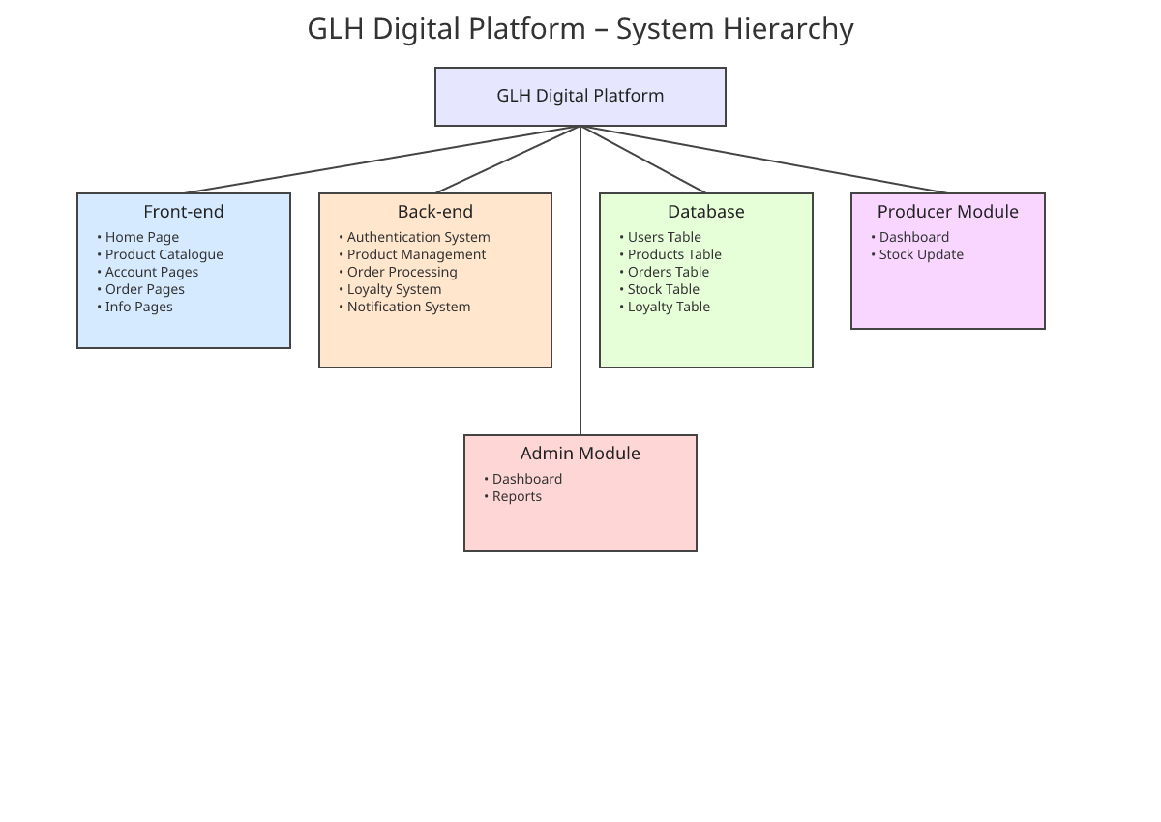
Problems to Solve and Impacts I have listed potential problems in development and usage, sorted by phase, with impacts and solutions.
Development Phase Problems
- Limited budget: Could delay hiring developers or buying tools. Impact: Incomplete system or rushed features. Solution: Use open-source software.
- Timeline issues: Not enough time for testing. Impact: More bugs in launch. Solution: Prioritise core modules.
- Integration errors: Front-end and back-end not connecting properly. Impact: Features fail, user frustration. Solution: Use API testing.
- Team knowledge gaps: Developers not familiar with React or Node.js. Impact: Delays in coding. Solution: Provide training.
User Registration/Login Problems
- Duplicate emails: Users try same email. Impact: Confusion or security risks. Solution: Check for uniques in database.
- Weak passwords: Users choose simple ones. Impact: Hacking risks. Solution: Enforce strength rules.
- Slow verification: Email delays. Impact: Users abandon sign-up. Solution: Use fast email service.
Product Browsing Problems
- Slow loading: Too many products. Impact: Users leave site. Solution: Optimise images and use pagination.
- Poor search: Inaccurate results. Impact: Can't find items, lost sales. Solution: Use advanced search algorithms.
- Inaccurate availability: Stock not updated. Impact: Orders for out-of-stock items. Solution: Real-time sync.
Ordering Problems
- Cart errors: Items disappear. Impact: Frustrated users. Solution: Session storage.
- Payment failure: Gateway issues. Impact: Lost sales. Solution: Backup payment options.
- Slot conflicts: Overbooked times. Impact: Delays. Solution: Lock slots on selection.
Producer Dashboard Problems
- Update fails: Database errors. Impact: Wrong stock shown. Solution: Transaction rollback.
- No real-time: Delays in updates. Impact: Overselling. Solution: WebSockets for live updates.
- Access issues: Wrong login. Impact: Producers miss orders. Solution: Role checks.
Loyalty Scheme Problems
- Point miscalculation: Math errors. Impact: Unfair discounts. Solution: Automated testing.
- Redemption errors: Failed at checkout. Impact: Lost trust. Solution: Validate points before apply.
Accessibility Problems
- Non-compliant features: No alt text. Impact: Exclude users, legal issues. Solution: WCAG audits.
- Settings not saved: Reset each time. Impact: Annoyance. Solution: Cookie storage.
Regulatory Problems
- Data leak: Security breach. Impact: GDPR fines. Solution: Encryption.
- Mislabelling: Wrong product info. Impact: FSA penalties. Solution: Admin reviews.
Breaking into modules allows focused development and testing. This decomposition reduces complexity.
7. Key Performance Indicators (KPIs)
KPIs measure success. I have listed them in a table, sorted by category (e.g., user-related, system-related).
KPI Category | KPI | Measurement Method | Target Value
User Adoption | Customer registration rate | Number of new accounts per month | 500 new users/month
User Adoption | Producer participation | Number of producers using dashboard daily | 40 producers/day
User Adoption | Loyalty enrolment | Percentage of customers in scheme | 60%
Sales | Order volume | Number of orders placed per week | 200 orders/week
Sales | Repeat customer rate | Percentage of customers ordering more than once | 50%
Sales | Sales growth | Increase in sales compared to previous month | 20% monthly
System Performance | Page load time | Average time to load pages | Under 2 seconds
System Performance | System uptime | Percentage of time system is available | 99.5%
System Performance | Error rate | Number of system errors per 1000 users | Under 5
Operations | Stock accuracy | Percentage of accurate availability | 98%
Operations | Delivery on time | Percentage of orders delivered as scheduled | 95%
Operations | Abandonment rate | Percentage of carts not completed | Under 30%
Feedback | User satisfaction | Average rating from feedback | 4.5/5
Feedback | Review count | Number of product reviews per month | 100 reviews/month
Accessibility | Accessibility usage | Number of users using features | 10% of users

These KPIs will be tracked using tools like Google Analytics and database queries. Targets are based on industry benchmarks to ensure success.
8. User Acceptance Criteria
User acceptance criteria define conditions for the system to be considered successful. I have listed them grouped by page or feature, with examples.
General Criteria
- The system must load without errors on supported browsers.
- Navigation links must work and highlight the current page.
- Footer links must redirect correctly.
- Consistent design (colours, fonts) across all pages.
- Accessibility panel must be available on all pages and save settings.
- System must handle invalid inputs with clear error messages.
Home Page Criteria
- Shows featured products, news, and promotions.
- Loads quickly and is responsive on mobile.
- Links to catalogue and other sections work.
Product Catalogue Criteria
- Displays all products with images, prices, and availability.
- Search bar returns relevant results.
- Filters (e.g., price, producer) narrow down options correctly.
- Clicking a product opens the detail page.
Product Detail Page Criteria
- Shows large image, name, price, description, producer info.
- Add to cart button updates the cart count.
- Reviews section allows adding ratings and comments.
Account Management Criteria
- Register form validates inputs (e.g., email format) and creates account.
- Login authenticates user and redirects to profile.
- Profile page allows updating details and shows order history.
- Password reset sends email and allows change.
Ordering Criteria
- Cart shows added items with totals.
- Checkout calculates price, applies discounts, and processes payment.
- Delivery/collection times are available and selectable.
- Confirmation email is sent after successful order.
- Order tracking shows current status (e.g., "Processing").
- Orders complete within 2 minutes for average user.
Loyalty Scheme Criteria
- Enrol button adds user to scheme.
- Points are earned correctly on purchases.
- Redemption reduces total at checkout.
- Points display accurately in account.
Producer Dashboard Criteria
- Login restricts access to producer role.
- Stock updates reflect in catalogue immediately.
- Product edits save changes without loss.
- Orders list shows relevant details.
Admin Dashboard Criteria
- Approving producers updates status.
- Reports generate accurate data (e.g., sales totals).
- Content updates appear on site.
Performance Criteria
- System handles 100 users simultaneously without slowdown.
- Accessibility features (e.g., screen reader) function correctly.
- Complies with all legal standards (e.g., GDPR).
These criteria will be tested with users to confirm the system is ready. They ensure functionality and usability.
9. Description of the Proposed Solution
The proposed solution is a web-based digital platform that connects customers and local food producers through a single online system. It will be developed using React for the front-end to create interactive webpages, React with Node.js for the back-end to handle data processing, authentication, and order management, and a SQLite database to store information such as customer accounts, product records, order history, and loyalty data.
Key Components and How They Work
- Front-end: Built with React for reactivity and user interfaces. Users see clean pages for browsing, ordering, and managing accounts. Will include some HTML and CSS as well.
- Back-end: Node.js with Express or similar to process requests, update database, and send emails/notifications.
- Database: SQLite for structured data storage, ensuring quick queries.
- Integration: Payment gateway (such as Stripe) and email service (such as SendGrid).
What Customers Can Do
- Browse locally produced products in a catalogue.
- View transparent pricing, availability, and producer stories.
- Place orders for delivery or collection with time slots.
- Track orders and view history in their account.
- Join a loyalty scheme to earn and redeem points.
What Producers Can Do
- Access a dashboard to manage stock levels in real time.
- Update product details like descriptions and images.
- View incoming orders and get notifications.
What Admins Can Do
- Manage users, approve producers, and generate reports.
- Update site content and monitor overall performance.
The platform will be responsive for mobile use and include accessibility features. Emerging technologies like blockchain for traceability could be added in future versions. The solution addresses GLH's needs by improving customer interaction and producer efficiency.
10. Justification – Meeting Client and User Needs
The proposed solution meets the needs of GLH, customers, and producers.
For GLH (Client):
- Supports cooperative goals by promoting local products online.
- Improves operational efficiency with digital stock and order management.
- Increases revenue through online sales and loyalty scheme.
- Ensures compliance with regulations like GDPR and FSA.
For Customers (Users):
- Provides convenient online access to local products.
- Offers transparent info on pricing, availability, and origins.
- Enables easy ordering, tracking, and account management.
- Includes loyalty rewards and accessibility for all.
For Producers (Users):
- Simplifies stock and product management with a dashboard.
- Boosts visibility and sales through the platform.
- Provides real-time orders and notifications for better planning.
The solution uses simple, scalable tech to meet these needs without overcomplicating. It justifies the investment by addressing problems like limited reach and inefficiency.
Risk Mitigation
Risk Category | Risk | Mitigation Strategy | Potential Impact if Not Mitigated
Security | Data security breach | Implement encryption and regular audits | Fines, loss of trust
Adoption | Low customer adoption | Simple interface, tutorials, marketing | Low sales, unused system
Technical | System downtime | Reliable hosting, backups | Lost orders, frustration
Operations | Stock inaccuracies | Real-time updates, validation | Overselling, refunds
Financial | Payment issues | Secure gateway, multiple options | Failed transactions
Legal | Accessibility problems | WCAG compliance, user testing | Lawsuits, excluded users
Growth | Scalability issues | Cloud-based, modular code | Crashes during peaks

Legal and Regulatory Considerations
- Data Protection (GDPR): Customer data stored securely, accessed only by authorised users, processed lawfully with consent.
- Consumer Protection Regulations: Accurate product info including pricing, availability, descriptions. 14-day returns policy.
- Accessibility Standards: Comply with Equality Act and WCAG for all users.
- Food Safety (FSA): Ensure traceability and labelling accuracy.
- Payment Security (PCI DSS): Secure card handling.
- Advertising (ASA): Truthful claims, no misleading info.
The system includes built-in features like consent forms and audits to meet these.

